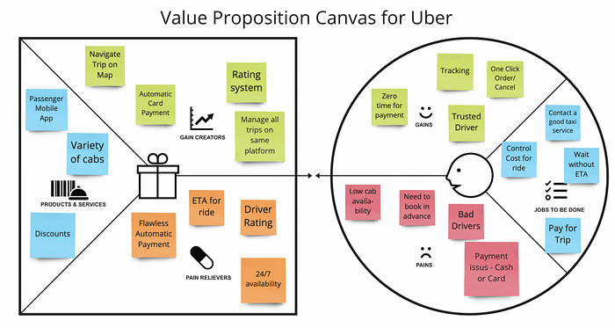

**Value Proposition Canvas Demonstration**

Objective: To help students understand how to use the Value Proposition Canvas to create a compelling value proposition for a software product.

**Procedure:**

1. Introduction:
   * Introduce the concept of the Value Proposition Canvas and its importance in software entrepreneurship.
   * Explain that the canvas is a visual tool that helps entrepreneurs clarify their value proposition and identify potential customers.
2. Explanation of the Canvas:
   * Explain each element of the Value Proposition Canvas, including the customer segment, value proposition, channels, customer relationships, revenue streams, and cost structure.
   * Provide examples of how each element should be filled in for a software product.
3. Group Activity:
   * Divide the class into groups of 3-4 students.
   * Provide each group with a printed copy of the Value Proposition Canvas template and a sample software product idea (e.g. a project management tool for remote teams).
   * Have each group fill in the canvas for their assigned product idea, using the elements explained in step 2.
   * Encourage them to be creative and think about how their product can provide value to their target customers.
4. Group Presentations:
   * Have each group present their completed Value Proposition Canvas to the class.
   * Encourage the class to ask questions and provide feedback on the group's value proposition.
5. Conclusion:
   * Summarize the key takeaways from the activity, including the importance of understanding customer needs and creating a compelling value proposition.
   * Encourage students to use the Value Proposition Canvas in their own software entrepreneurship projects.

**Assessment:**

* Observe each group's progress during the activity and assess their understanding of the Value Proposition Canvas.
* Evaluate the completeness and clarity of each group's canvas, including whether they have identified a clear customer segment, value proposition, and revenue streams.
* Assess the creativity and originality of each group's value proposition and whether it addresses a real need in the market.